**National University of Computer & Emerging Sciences (NUCES) Islamabad,**

Department of Computer Science

**Programming Fundamentals – Fall 2022**

**LAB 05**



**Learning Outcomes**

In this lab you are expected to learn the following:

* Relational operators
* Logical operators
* Type casting

**Relational operators and Logical operators**

In C++, relational and logical operators compare two or more operands and return either true or false values. We use these operators in decision making. If the relation is true, it returns 1 whereas if the relation is false, it returns 0. The following table summarizes the relational operators used in C++.

|  |  |  |
| --- | --- | --- |
| Operator | Meaning | Example |
| == | Is Equal To | 3 == 5 gives us false |
| != | Not Equal To | 3 != 5 gives us true |
| > | Greater Than | 3 > 5 gives us false |
| < | Less Than | 3 < 5 gives us true |
| >= | Greater Than or Equal To | 3 >= 5 give us false |
| <= | Less Than or Equal To | 3 <= 5 gives us true |

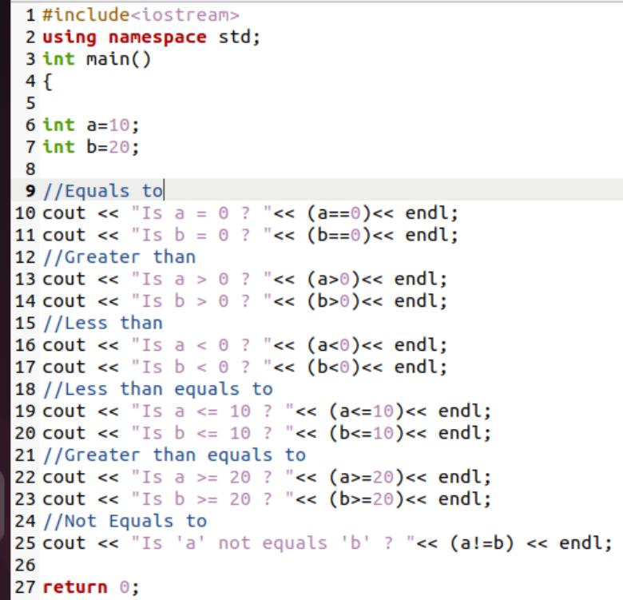

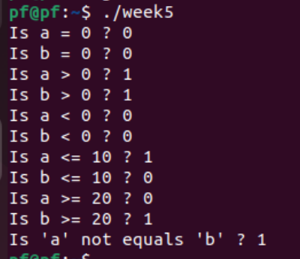

**Type casting**

type cast is basically a conversion from one type to another. There are two types of type conversion:

1. Implicit Type Conversion Also known as ‘automatic type conversion’. Done by the compiler on its own, without any external trigger from the user. Generally takes place when in an expression more than one data type is present. In such condition type conversion (type promotion) takes place to avoid lose of data. All the data types of the variables are upgraded to the data type of the variable with largest data type.

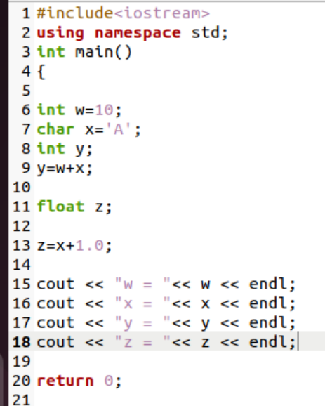

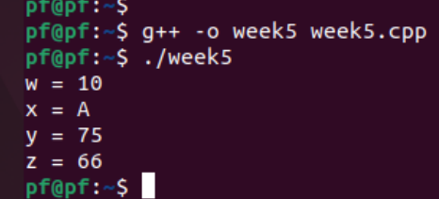

1. Explicit Type Conversion: This process is also called type casting and it is user-defined. Here the user can typecast the result to make it of a particular data type.

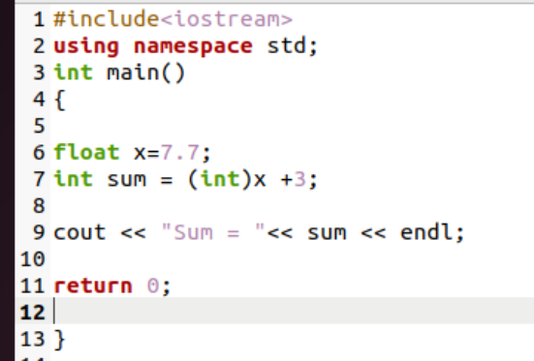

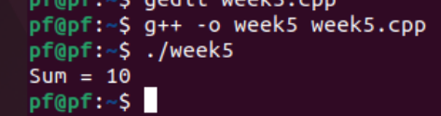

**Practice Tasks**

**Task 1:**

Write a program to take a 3-digit integer input from the user and display the sum of all digits.

For example, input: 432

Output: 9

**Task 2:**

If the marks of Robert in three subjects are 78,45 and 62 respectively (each out of 100), write a program to calculate his total marks and percentage marks.

**Task 3:**

Calculate the asci sum of your first name.

**Task 4:**

Write a program to calculate the weekly wage of an employee who is paid @ Rs 1000/hr for 40 hours and overtime is paid at Rs 1500/hr. The user will enter integer number of hours the employee worked.

**Task 5:**

Find the result of the following operations:

1. 5+4
2. 10/2
3. True OR False
4. 20 MOD 70
5. 5<8
6. 25 MOD 70
7. NOT True
8. 25\70
9. False AND True
10. 20*0.5
11. 35<=35
12. 35/7
13. False OR False
14. True AND True
15. 50 MOD 5
16. -35/67

**Task 6:**

Find root of some quadratic equation ax²+bx+c=0 using the quadratic formula as:

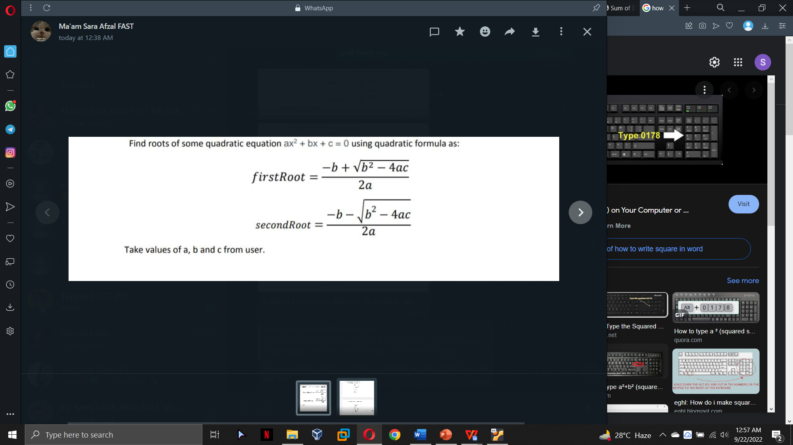

Take values of a, b and c from the user.

**Submission Instructions:**

1. Save all .cpp files with your lab no, roll no and task number e.g. LAB1_i21XXXX_Problem01.cpp
2. Take the screenshots of your program outputs showing on the terminal.
3. Submit all .cpp files and 1 or 2 screenshots of all program outputs directly on Google Classroom (Don’t submit the zip folder).